- National accounts revisions confirmed that the UK's post-pandemic recovery was slightly stronger than initially thought. But a big downward revision to the saving ratio suggests less scope for dissaving from the household sector, so we plan to nudge down our 2025 GDP growth forecast.
- September's S&P Global survey reported signs of softer inflation. Meanwhile, Bank of England Governor Andrew Bailey opened the door to a more aggressive pace of rate cuts this week, stating that if the good news on inflation persisted, the Bank could become "a bit more activist".
In a busy week of economic releases, the Office for National Statistics' Quarterly National Accounts for Q2 was the most important. Beyond the usual quarterly revisions, the publication also included methodological improvements to be introduced in the annual Blue Book, incorporated more detailed but less timely data sources, and saw the data rebased to 2022 prices from 2019 prices.
The revisions did little to change the story around headline GDP, but there were signs that the consumer might offer less support to growth than we had hoped in the coming years. As had been trailed by the ONS, GDP growth in 2022 was revised up by 0.5ppts to 4.8%, confirming that the post-Covid recovery was stronger than originally anticipated. But there were minimal changes to GDP across 2023 and 2024. The most notable change was a 0.1ppt downward revision to activity in Q2 2024. But this still left growth at 0.5% q/q and the story of the economy building solid momentum in H1 2024 remained intact.
Digging into the detail, the most striking feature of the National Accounts was large downward revisions to the household saving ratio. Though it is still reported to have risen sharply in recent quarters, the saving ratio has been revised much lower since the end of 2021, so much so that we now know it was below the 2010-2019 average for an 18-month period in 2022-2023 (Chart 1). This new evidence contrasts with the previous story that the weakness in consumer spending in recent years was partly attributable to households continuing to build significant excess savings, even after the pandemic had ended.
Chart 1: Though still rising, the household saving ratio is much lower than previously thought
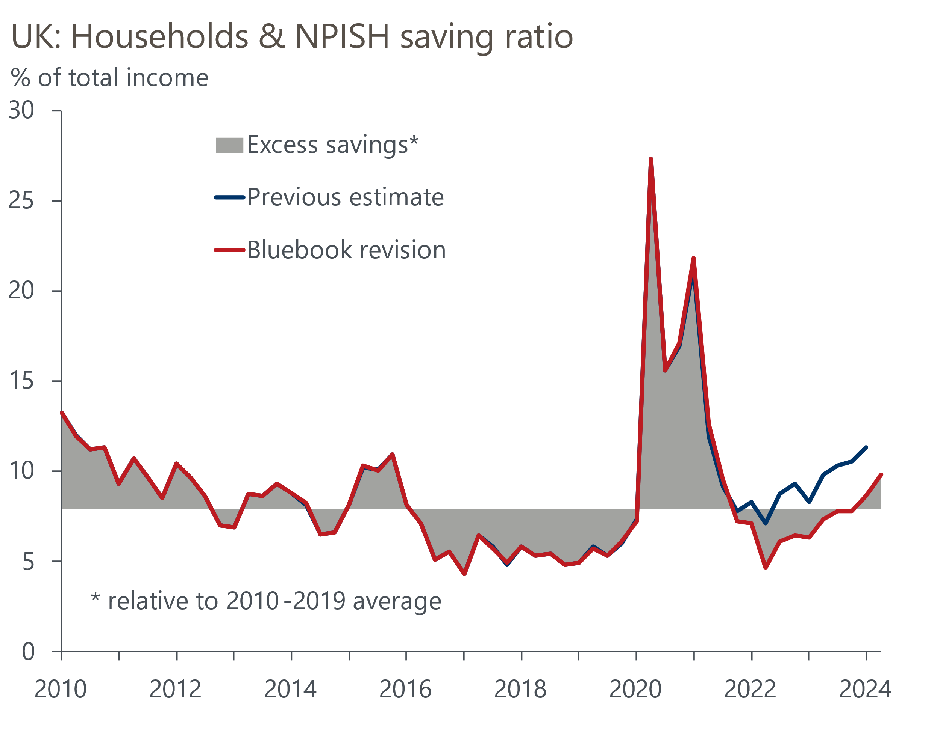
Sources: Oxford Economics, Haver Analytics, ONS

We've always expected quarterly GDP growth to slow in H2 2024, and on the surface, September's final S&P Global survey suggested the slowdown might be more marked. There was a sharp fall in the composite PMI to 52.6 from 53.8 in August, owing to declines in both the services PMI and manufacturing production.
However, we don't see the decline in the composite PMI as a cause for concern. The survey outturns can be volatile from month-to-month and history suggests there's a seasonal pattern to the results, with the index often falling in September. Moreover, September's composite reading is only slightly below the average for the first nine months of the year and the PMIs remain comfortably above the 50 'no-change' mark, signalling a solid pace of expansion (Chart 2). So we think the economy still enjoys good momentum, even though GDP growth is likely to come in softer in Q3 than the above-trend rates seen in H1 2024.
Chart 2: Though the composite PMI declined in September, it still points to healthy GDP growth in Q3
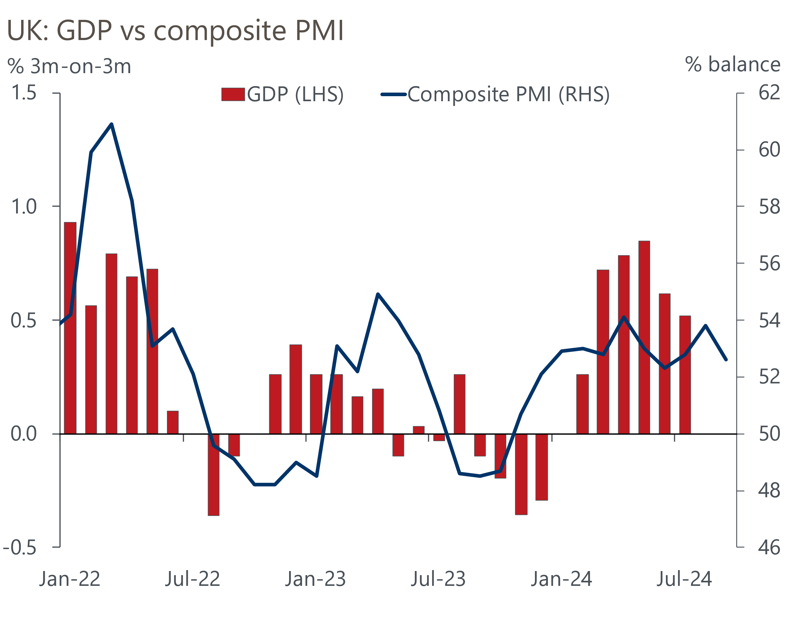
Sources: ONS, S&P Global
We will publish an updated forecast on October 9, which will include the new national accounts data. The downward revision to GDP in Q2 2024 will likely shave 0.1ppt off our existing 2024 GDP growth forecast. Meanwhile, the new data on the household sector suggests less scope for dissaving to boost consumer spending growth. As a result, we're likely to cut our forecast for GDP growth in 2025 by around 0.2ppts.
September's S&P Global survey also offered some good news on the inflation front. Though input cost inflation ticked up slightly, output prices rose at the slowest pace since February 2021 as competitive pressures weighed on firms' pricing power.
Bank of England Governor Andrew Bailey noted in an interview with the Guardian newspaper this week that "if the news on inflation continued to be good, there was a chance of the Bank becoming a bit more activist in its approach to cutting rates". Market pricing reacted strongly to what was a much more dovish message than we'd previously seen from the Governor.
Still, the Monetary Policy Committee remains deeply divided on the pace of the rate-cutting cycle. Speaking this morning at a conference hosted by the ICAEW, BoE Chief Economist Huw Pill struck a much more cautious tone when discussing the prospect of further rate cuts, arguing that "it will important to guard against the risk of cutting rates either too far or too fast" and "the need for caution points to a gradual withdrawal of monetary restriction".
Given that Bailey's camp has outnumbered Pill's, we see the Governor's comments as being more representative of the general mood of the MPC. Having paused in September, we think it's almost certain that a majority will vote to cut rates by 25bps at the November meeting. The chances of another cut in December are certainly increasing. But we think the Budget on October 30 is likely to be a decisive factor in whether Bailey's camp decides to step up the pace of rate cuts, particularly given the recent speculation that the fiscal rules will be changed in a way that allows looser fiscal policy.

The week ahead
The GDP data for August is next week's only major release. Though output was flat in July, that masked some large divergences at the sectoral level, and several of July's large downward movements are likely to have unwound in August – most notably in the manufacturing, construction, and professional services sectors. In addition, we know that retail sales volumes rose strongly in August, so we expect that distribution output made a chunky positive contribution to growth. So on balance, we estimate that GDP rose by 0.3% m/m in August.
Table 1: Week ahead calendar
Date | Events | Period | Measure | Unit | Previous | Forecast
Oct 7 | Halifax house prices | Sep | m/m | % | 0.3 | 0.3
Oct 7 | Halifax house prices | Sep | y/y | % | 4.3 | 5.2
Oct 11 | GDP | Aug | m/m | % | 0.0 | 0.3
Oct 11 | GDP | Aug | 3m/3m | % | 0.4 | 0.3
Oct 11 | Index of services | Aug | m/m | % | 0.2 | 0.3
Oct 11 | Index of services | Aug | 3m/3m | % | 0.4 | 0.2
Oct 11 | Manufacturing output | Aug | m/m | % | -1.0 | 0.3
Oct 11 | Manufacturing output | Aug | y/y | % | -1.8 | -0.9
Oct 11 | Industrial production | Aug | m/m | % | -0.5 | 0.4
Oct 11 | Industrial production | Aug | y/y | % | -2.0 | 1.5
Oct 11 | Construction output | Aug | m/m | % | -0.4 | 0.2
Oct 11 | Construction output | Aug | y/y | % | -1.3 | 0.0
Oct 11 | UK trade | Aug | Trade balance | £bn | -7.5 | -6.9
Oct 11 | UK trade | Aug | Visible balance | £bn | -20.0 | -18.7
Source: Oxford Economics

Key forecasts
Table 2: UK forecast overview (table does not include this week's revised National Accounts data)
(Annual percentage changes unless specified)
 | 2022 | 2023 | 2024 | 2025 | 2026 | 2027
GDP | 4.3 | 0.1 | 1.1 | 1.7 | 1.8 | 1.7
Private consumption | 4.8 | 0.2 | 0.6 | 2.1 | 2.0 | 1.6
Fixed investment | 8.0 | 2.2 | 0.3 | 0.9 | 2.5 | 2.1
Government consumption | 2.3 | 0.5 | 2.7 | 2.8 | 1.6 | 1.5
Exports of goods and services | 9.0 | -0.5 | -1.1 | 2.1 | 2.0 | 1.7
Imports of goods and services | 14.6 | -1.5 | 0.8 | 2.5 | 2.6 | 1.9
Industrial Production | -3.5 | -0.4 | -0.1 | 0.8 | 1.5 | 1.1
Consumer prices | 9.1 | 7.3 | 2.5 | 2.5 | 2.3 | 2.1
Unemployment rate (%) | 3.9 | 4.0 | 4.3 | 4.3 | 4.1 | 3.9
Current a/c balance (% of GDP) | -3.1 | -3.3 | -3.6 | -3.2 | -3.2 | -3.2
Government balance (% of GDP) | 4.2 | 5.0 | 4.0 | 3.2 | 2.5 | 1.7
Cen. bank policy rate (%, EOP) | 3.50 | 5.25 | 4.75 | 3.75 | 2.75 | 2.00
10yr govt. bond yield (%, EOP) | 3.67 | 3.54 | 3.93 | 3.67 | 3.24 | 2.85
Exchange rate (US$ per £, EOP) | 1.20 | 1.27 | 1.29 | 1.30 | 1.31 | 1.33
Exchange rate (euro per £, EOP) | 1.13 | 1.15 | 1.19 | 1.19 | 1.18 | 1.17
Source: Oxford Economics
Table 3: Quarterly forecasts for the UK
 | 2024 |  |  |  | 2025
 | Q1 | Q2 | Q3 | Q4 | Q1 | Q2 | Q3 | Q4
GDP (% year) | 0.3 | 0.9 | 1.3 | 2.1 | 1.8 | 1.6 | 1.7 | 1.7
CPI inflation (% year) | 3.5 | 2.1 | 2.1 | 2.4 | 2.5 | 2.3 | 2.7 | 2.6
Bank Rate (%, EOP) | 5.25 | 5.25 | 5.00 | 4.75 | 4.50 | 4.25 | 4.00 | 3.75
10yr gilt yield (%, EOP) | 3.95 | 4.17 | 3.95 | 3.93 | 3.87 | 3.80 | 3.74 | 3.67
US$ per £ (EOP) | 1.26 | 1.26 | 1.30 | 1.29 | 1.29 | 1.29 | 1.30 | 1.30
Euro per £ (EOP) | 1.17 | 1.18 | 1.19 | 1.19 | 1.19 | 1.19 | 1.19 | 1.19
Source: Oxford Economics

Latest Country Economic Forecast:
September 13, 2024

Recent publications

Data Insights
Services PMI points to healthy, albeit slower, GDP growth in Q3
Manufacturing PMI ended Q3 on a softer note
Lower mortgage rates supported a jump in approvals in August
GDP revisions consolidate recovery
PMIs point to steady growth in Q3

Research Briefings
MPC takes a breath, but cuts likely to resume in November
MPC preview – Pace of gilts sell-off is the key decision
MPC easing - how far and how fast?
Growth may slow, but the consensus looks too weak
Rate-cut cycle kicks off but it’s unlikely to be sequential

Contacts

Oxford Economics' UK team
- Andrew Goodwin - Chief UK Economist - agoodwin@oxfordeconomics.com
- Edward Allenby - UK Economist - eallenby@oxfordeconomics.com

